Analysis of Factors Affecting the Risk Level of Kidney Disease Using Ordinal Logistic Regression
Marcell Prasetyo
BINUS University
Jakarta, Indonesia
marcell.prasetyo@binus.ac.id
Nusantara Kusuma
BINUS University
Jakarta, Indonesia
nusantara.kusuma@binus.ac.id
Ricardo Xavier Rinzi
BINUS University
Jakarta, Indonesia
ricardo.rinzi@binus.ac.id

Abstract—Chronic Kidney Disease (CKD) is a serious worldwide health concern that has complicated risk factors and is becoming more common. An ordinal logistic regression model is used in this study to find important factors that affect CKD risk levels. There are five phases of CKD risk: No Disease, Low Risk, Moderate Risk, High Risk, and Severe Disease. This was determined by using a dataset that included 20,538 observations and 43 clinical, demographic, and lifestyle variables. Four factors—specific gravity of urine, presence of white blood cells in urine (pus cells), appetite, and estimated glomerular filtration rate (eGFR)—were found to have a substantial impact on CKD risk levels. Remarkably, a number of variables that were previously thought to be important—including age, BMI, diabetes, and hypertension—were not statistically significant in this investigation. These results point to characteristics that could be given priority in early identification and preventive initiatives and emphasize the significance of assessing the progression of CKD using ordinal approaches.
Keywords—chronic kidney disease, ordinal logistic regression, medical risk, machine learning, disease severity classification.

Introduction

Background

According to research by Webster, A. C., et al. (2017), chronic kidney disease (CKD) is characterized by kidney damage or an estimated glomerular filtration rate less than 60 mL/min/1.73m², persisting for 3 months or longer. Meanwhile, according to research by Arora, P. (2025), CKD encompasses all levels of declining kidney function, ranging from risk of damage to mild, moderate, and severe chronic kidney failure. CKD leads to progressive loss of kidney function, often necessitating kidney replacement therapy, such as transplantation.

This disease represents a significant global health issue with steadily increasing prevalence year after year. Based on the GDB Chronic Kidney Disease Collaboration report (2020), individuals with CKD at all stages reached nearly 700 million in 2017. With 1.2 million deaths in 2017, projections indicate an increase to between 2.2 and 4 million by 2040. CKD ranks as the 12th leading cause of death among 133 diseases. In Indonesia specifically, according to the Riskesdas Team (2018), CKD prevalence reached 0.38% of the total population in 2018. According to research by Levin, A., et al. (2017), while many causes of CKD are known, such as diabetes, hypertension, vascular disease, or glomerulonephritis, other causes remain uncertain in some affected individuals, hindering methods to prevent, mitigate, and cure CKD.

CKD exhibits complex characteristics with numerous interconnected risk factors. According to research by Francis, A., et al. (2024), population growth, obesity, aging, smoking, and the increasing burden of diabetes, heart disease, and hypertension are driving CKD cases. Environmental factors also play a role, such as climate change, water and air pollution, and extreme heat. However, these risk factors alone are insufficient to identify the primary factors causing CKD.

In recent decades, machine learning approaches have been used to detect factors and predict CKD. Research by Ilyas, H., et al. (2021) used two algorithms, with the J48 algorithm showing the highest overall accuracy at 85.5%, but without analyzing relationships between predictor variables and their relationships with the target variable.

Research by Tekale, S. et al. (2018) used two algorithms, with the SVM algorithm showing the highest overall accuracy at 96.75%, but without analyzing relationships between predictor variables and their relationships with the target variable.

Research by Tabassum, S., et al. (2017) used three algorithms, with the most significant variable being SpecificGravity based on the Decision Tree of C4.5 algorithm. The C4.5 algorithm showed the highest overall accuracy at 96.75%, but without analyzing relationships between predictor variables and their relationships with the target variable.

Research by Islam, M. A., et al. (2023) used 12 algorithms, with the most significant variable being Hemoglobin based on correlation heat map and Serum creatinine based on feature selection with PCA. The XgBoost, LGBM, and Hybrid algorithm showed the highest overall dataset without PCA accuracy at 98.3% and The XgBoost showed the highest overall dataset with PCA accuracy at 99.2%.

Research by Halder, R. K., et al. (2024) used 7 algorithms, with the most significant variables being Hypertension, Diabetes Mellitus, Albumin, and Serum creatine based on overall feature selection methods. The Random Forest and AdaBoost showed the perfect overall accuracy at 100%, but without analyzing the ordinal structure of disease status.

Although these studies help predict CKD, methodological limitations must be addressed. Most of the disease status has typically been treated as nominal, with no regard for ordinal relationships, resulting in a lack of information about disease progression. As a result, this study uses an ordinal logistic regression approach to investigate relationships between categorical variables and CKD status at various levels (No_Disease, Low_Risk, Moderate_Risk, High_Risk, Severe_Disease). This method not only models disease status using risk factors, but it also explains how each variable affects the ordinal structure of disease status.

Problem Foundation

- How do the available factors significantly affect the risk level of kidney disease?
- Why is it important to identify the most influential factors in determining the ordinal categories of kidney disease risk?
- Why is it important to know which variables have a significant influence on the risk of kidney disease in patients?

Objectives

- Identify significant variables that affect the risk level of kidney disease.
- To construct an ordinal logistic regression model for predicting kidney disease risk levels.
- Provide interpretation of the results of the significance analysis to determine the factors that need to be considered in efforts to prevent kidney disease.

Benefits

- In general

Increase awareness of the importance of maintaining kidney health through the identification of relevant risk factors.

- For medical personnels

Provide data-driven information to assist in the initial screening process of patients at risk of kidney disease.

- For future researchers

Become the basis for further research that can develop machine learning-based early detection systems or the development of health recommendation systems.

Theoretical study

The quality of life of those who suffer from Chronic Kidney Disease (CKD) is greatly impacted by this extremely complex worldwide health issue. The fundamental ideas, pathophysiology, epidemiology, risk factors, diagnosis techniques, and statistical analysis strategies employed in this investigation will all be covered in this section.

A state of kidney damage or a reduced glomerular filtration rate (GFR) of less than 60 mL/min/1.73 m² that persists for three months or more is known as chronic kidney disease (CKD). According to research by Kadatane, S. P, et al (2023), from low-risk to advanced chronic kidney failure necessitating kidney replacement therapy, both types of kidney function decline are included in chronic kidney disease (CKD).

As kidney function gradually deteriorates, chronic kidney disease (CKD) can eventually result in end-stage kidney disease (ESRD) or terminal kidney failure that necessitates dialysis or kidney transplantation. According to research by Tangri, N. (2023), eGFR, or estimated glomerular filtration rate, is the primary metric used to evaluate kidney function and categorize the severity of chronic kidney disease.

CKD is divided into stages according to eGFR values:
Stage 1: kidney impairment is evident with an eGFR of 90 mL/min/1.73 m².
Stage 2: eGFR with signs of kidney impairment, 60-89 mL/min/1.73 m².
eGFR 45–59 mL/min/1.73 m² is stage 3a.
eGFR 30-44 mL/min/1.73 m² is stage 3b.
eGFR 15–29 mL/min/1.73 m² is stage four.
Stage 5: dialysis or eGFR <15 mL/min/1.73 m².

Chronic kidney disease (CKD) has grown to be a major global public health issue. According to the Global Burden of Disease (GBD) Chronic Kidney Disease Collaboration report, over 700 million people worldwide were expected to have CKD in one form or another in 2017. By 2040, the number of deaths from CKD is expected to rise from 1.2 million in 2017 to 2.2 to 4 million. According to research by Hu, J., et al (2020), Currently, CKD is currently the 12th most common cause of death of the 133 diseases that have been investigated.

There is a high frequency of undiagnosed stage 3 CKD, according to the REVEAL-CKD study, which was carried out in five countries: France, Germany, Italy, Japan, and the United States. According to research by Tangri, N. (2023), the percentage of people with undiagnosed chronic kidney disease (CKD) was 95.5% in France, 84.3% in Germany, 77.0% in Italy, 92.1% in Japan, and roughly 61.6%–64.3% in the USA. This highlights the significance of CKD risk factor identification and early detection.

According to 2018 data from Basic Health Research (Riskesdas), the prevalence of chronic kidney disease (CKD) in Indonesia was 0.38 percent of the population. According to research by Dharmapatni, N. W. K., et al. (2024), this number is thought to be lower than the true prevalence since, like the global trend, many instances remain undetected. One of the reasons for Indonesia's high kidney disease burden is the lack of early diagnosis.

CKD pathophysiology involves a number of intricate pathways. There are several causes of first kidney damage, such as glomerulonephritis, diabetes mellitus, hypertension, and autoimmune disorders. According to research by Kadatane, S. P, et al (2023), even if the original source of the disease has been addressed, adaptive and maladaptive mechanisms continue to induce disease development after the first damage has occurred.

According to recent research, low-grade persistent inflammation plays a significant role in the onset and advancement of chronic kidney disease. An imbalance between pro-inflammatory and anti-inflammatory markers causes this chronic inflammation. According to research by Kadatane, S. P, et al (2023), this imbalance may be caused by a number of causes, including gut dysbiosis, periodontal disease, reactive oxygen species (ROS) generation, innate immune system activation, and dysregulation of the anti-inflammatory system.

Kidney fibrosis, hypertension, and a rapid loss in kidney function are all consequences of chronic inflammation. According to research by Kadatane, S. P, et al (2023), chronic low-grade inflammation has been linked to a higher risk of cancer in people with chronic kidney disease.

CKD is largely caused by glomerulonephritis, a class of illnesses that damage the kidney glomerulus. According to data from the 2019 Global Burden of Disease Study, glomerulonephritis-related CKD accounted for 183,700 fatalities in 2019, while 606,300 new patients were diagnosed. Additionally, 17,300,000 persons were living with CKD. According to research by Hu, J., et al (2020), new patients climbed by 77%, patients with the disease increased by 81%, and deaths increased by 100% in comparison to 1990.

Early detection and prevention of CKD depend on the identification of risk factors. The following are some of the main risk factors that have been found:

- Diabetes mellitus
One of the main causes of CKD in the world is diabetes. Diabetic nephropathy is the result of long-term hyperglycemia that damages the kidney's tiny blood capillaries. According to research by Dharmapatni, N. W. K., et al. (2024), the odds ratio for CKD is 6.571 (p-value = 0.010) for people with a history of diabetes mellitus. Diabetes mellitus is also one of the most significant variables based on research by Halder, R. K., et al. (2024).

- High blood pressure
The kidney blood vessels gradually deteriorate due to high blood pressure. One of the main risk factors for CKD is uncontrolled hypertension, which can hasten the course of the illness. According to research by Mardianto, R., et al. (2022), it has been demonstrated that antihypertensive medication adherence can reduce kidney problems and impact patients' quality of life. Hypertension is also one of the most significant variables based on research by Halder, R. K., et al. (2024).

- Family History
The risk of CKD is significantly influenced by genetic factors. According to research by Dharmapatni, N. W. K., et al. (2024), with an odds ratio of 4.354 (p-value = 0.037), those with a family history of kidney illness are more likely to acquire chronic kidney disease (CKD). This implies how crucial it is to screen people with a clean family history.

- Age
As people age, the prevalence of CKD rises. Kidney function decline is a natural aspect of aging, but it can be sped up by a number of additional risk factors. According to research by Hu, J., et al (2020), decomposition analysis, one of the primary causes of the rising worldwide burden of CKD is population aging.

- Lifestyle and Obesity
CKD risk has been linked to smoking, a high body mass index (BMI), and a poor level of physical exercise. According to research by Kadatane, S. P, et al (2023), with the right interventions, these lifestyle factors can be changed to lower the risk of CKD.

- Inflammatory Biomarkers
Interleukin-6 (IL-6) and C-reactive protein (CRP) are inflammatory biomarkers linked to the onset and advancement of chronic kidney disease. According to research by Kadatane, S. P, et al (2023), CKD patients' risk and prognosis may be evaluated with the aid of these biomarkers' values.

CKD is diagnosed using a number of clinical and laboratory criteria, including:

- Glomerular Filtration Rate Estimate (eGFR)
The main metric used to evaluate kidney function is eGFR. A criterion for diagnosing chronic kidney disease (CKD) is an eGFR value of less than 60 mL/min/1.73m² that lasts for at least three months. According to research by Tangri, N. (2023), the CKD-EPI or MDRD calculation, which is based on serum creatinine levels, age, gender, and race, is typically used to calculate eGFR. Serum creatinine is also one of the most significant variables based on research by Islam, M. A., et al. (2023) and Halder, R. K., et al. (2024).

- Albuminuria
One indicator of kidney impairment is albuminuria, or the presence of albumin in the urine. The degree of albuminuria is measured using the urine albumin-creatinine ratio (UACR). According to research by Tangri, N. (2023), Kidney injury is indicated by UACR ≥30 mg/g. Albumin is also one of the most significant variables based on research by Halder, R. K., et al. (2024).

- Additional lab parameters
According to research by Kadatane, S. P, et al (2023) and research by Hu, J., et al (2020), blood urea nitrogen (BUN) levels, electrolytes (potassium, sodium), calcium, phosphate, and hematological markers (hemoglobin, hematocrit) are among the laboratory parameters that are used to evaluate kidney function and problems associated with chronic kidney disease (CKD). Hemoglobin is also one of the most significant variables based on research by Islam, M. A., et al. (2023).

One statistical technique for examining the association between independent variables (predictors) and dependent variables (outcomes) with an ordinal scale is ordinal logistic regression. This extension of binary logistic regression enables the analysis of outcome variables with more than two naturally ordered categories.

The risk level for kidney disease, which is divided into five categories—No Disease, Low Risk, Moderate Risk, High Risk, and Severe Disease—is an ordinal outcome variable in the context of CKD study. The proportional odds assumption of the ordinal logistic regression model states that the effects of predictor variables are constant across outcome categories.

Methodology

Data Description

The Kidney Disease Dataset is a rich collection of clinical and laboratory data from patients curated to support the analysis, diagnosis and prediction of chronic kidney disease (CKD). The dataset includes 43 diverse features, including demographic details, vital signs, urine and blood test results, medical history, lifestyle factors, and biomarkers such as serum creatinine, eGFR, and Cystatin C. The dataset is well suited for building machine learning models. This dataset is perfect for building machine learning models. Researchers and healthcare professionals seeking to detect and manage kidney disorders early have access to the valuable resources of this dataset.

This dataset consists of detailed clinical information related to kidney health, intended for machine learning, statistical analysis, and health research applications.

The dataset used in this study is “kidney_disease_dataset.csv” which contains 20,538 observation data of patients and 43 variable columns. The target variable or dependent variable (y) is the “Target” column which classifies the risk level of kidney disease into five levels:

- No_Disease
- Low_Risk
- Moderate_Risk
- High_Risk
- Severe_Disease

Independent variables (x) include various clinical and lifestyle aspects, such as:

Var | Name | Description | Measurement scale
x1 | Age.of.the.patient | Age of the patient | Ratio
x2 | Blood.pressure  ..mm.Hg. | Systolic/  diastolic  blood  pressure  measured  in mm/Hg | Ratio
x3 | Specific.  gravity.  of.urine | Concentration of urine used to assess kidney filtering ability | Ratio
x4 | Albumin.in.urine | Presence of albumin protein in urine | Nominal
x5 | Sugar.in.urine | Glucose content in urine | Ratio
x6 | Red.blood.cells.in.urine | Presence of red blood cells in urine | Nominal
x7 | Pus.cells.in.urine | Presence of white blood cells in urine | Nominal
x8 | Pus.cell.clumps.in.urine | Presence of severe urinary infection | Nominal
x9 | Bacteria.in.urine | Detection of bacterial infection | Nominal
x10 | Random.blood.glucose.level..mg.dl. | Blood glucose level measured at any random time | Ratio
x11 | Blood.urea..mg.dl. | Blood urea level | Ratio
x12 | Serum.creatinine..mg.dl. | Serum creatinine level | Ratio
x13 | Sodium.level..mEq.L. | Sodium level | Ratio
x14 | Potassium.level..mEq.L. | Potassium level | Ratio
x15 | Hemoglobin.level..gms. | Hemoglobin level | Ratio
x16 | Packed.cell.volume.... | Packed cell volume | Ratio
x17 | White.blood.cell.count..cells.cumm. | White blood cell count | Ratio
x18 | Red.blood.cell.count..millions.cumm. | Red blood cell count | Ratio
x19 | Hypertension..yes.no. | Presence of hypertension | Nominal
x20 | Diabetes.mellitus..yes.no. | Presence of diabetes mellitus | Nominal
x21 | Coronary.artery.disease..yes.no. | Presence of coronary artery disease | Nominal
x22 | Appetite..good.poor. | Appetite condition | Nominal
x23 | Pedal.edema..yes.no. | Presence of pedal edema | Nominal
x24 | Anemia..yes.no. | Presence of anemia | Nominal
x25 | Estimated.Glomerular.Filtration.Rate..eGFR. | Estimated Glomerular Filtration rate | Ratio
x26 | Urine.protein.to.creatinine.ratio | Protein to creatinine ratio in the urine | Ratio
x27 | Urine.output..ml.day. | Urine output per day | Ratio
x28 | Serum.albumin.level | Serum albumin level | Ratio
x29 | Cholesterol.level | Cholesterol level | Ratio
x30 | Parathyroid.hormone..PTH..level | Parathyroid hormone level | Ratio
x31 | Serum.calcium.level | Serum calcium level | Ratio
x32 | Serum.phosphate.level | Serum phosphate level | Ratio
x33 | Family.history.of.chronic.kidney.disease | Presence of chronic kidney disease within the patient's family history | Nominal
x34 | Smoking.status | Smoking status of the patient | Nominal
x35 | Body.Mass.Index..BMI. | Body mass index of the patient | Ratio
x36 | Physical.activity.level | The patients physical activity level | Nominal
x37 | Duration.of.diabetes.mellitus..years. | The duration of which the patient diabetes mellitus hypertension | Ratio
x38 | Duration.of.hypertension..years. | The duration of which the patient experiences hypertension | Ratio
x39 | Cystatin.C.level | Cystasin C level | Ratio
x40 | Urinary.sediment.microscopy.results | Urinary sediment microscopy results | Nominal
x41 | C.reactive.protein..CRP..level | C reactive protein (CRP) level | Ratio
x42 | Interleukin.6..IL.6..level | Interleukin 6 level | Ratio

* Note: Our team accessed this dataset for the first time in Kaggle on the 18th of May 2025 and based on our findings, this dataset was used in the context of machine learning and predictive model building. In the process of constructing this research paper, our team has not found any other research using this dataset in the context of applying Ordinal Logistic Regression to find which predictor variables are significant. This part was constructed as a notice that our team’s work is NOT plagiarized in any way, shape, or form from other researches that are merely used as references and that our findings within this research are entirely our own.

Ordinal Logistic Regression

According to research by Agresti, A. (2010), ordinal logistic regression is a statistical method used to analyze relationship between one or more independent variable and an ordinal dependent variable, where the categories have a natural order but unknown distances (Example: Strongly Disagree, Disagree, Neutral, Agree, Strongly Agree).

This model employs the cumulative logit model and assumes that the relationship between independent variables and cumulative probabilities of the outcome categories can be modeled linearly on the logit scale. In this framework, two sets of parameters must be interpreted, the regression coefficients (β), which describes the effect of each independent variable on the log odds of being in or below a category and the thresholds or intercepts (α), which define the boundaries between adjacent response categories.

The ordinal logistic regression model requires the following assumptions to be met:
- Proportional odds assumption, the odds ratio between neighboring categories is constant across all levels of the independent variable.
- Independence of observation, observations should be independent of one another.
- No multicollinearity, independent variables should not be substantially associated with one another.
- Linearity, the logit is linearly related to the continuous independent variables.

Parameter estimation can be approached using maximum likelihood estimation (MLE), which simultaneously estimates both parameters under the assumption of proportional odds. Alternatively, research by Paterson, B. and Harrel, F. E. (1990) and later extended by Fullerton, A. S. (2009) proposes a more flexible alternative known as the partial proportional odds model (PPOM). This method allows some predictor variables to have category specific effects if the proportional odds assumption is violated.

There are numerous approaches for evaluating the ordinal logistic regression model:

- The Goodness of Fit Test is performed using statistics such as Pearson chi-squared or Deviance.
- Pseudo R-squared is calculated using McFadden R-squared, Nagelkerke R-squared, or Cox and Snell R-squared.
- Classification accuracy, the percentage of correct predictions from the model.

According to research by Arango-Botero, D., et al (2023), the likelihood ratio test (LRT) compares two nested models. LRT operates on the assumption that if the null hypothesis is true, the simpler model (limited model) will produce a likelihood that is not statistically different from the more complex model (unrestricted model).

Advantages of LRT include:
- Has optimal features in the Neyman-Pearson decision theory.
- Invariant under parameter transformation
- Can be used for sophisticated hypothesis tests.

The limitations of LRT include:
- Need strict regularity criteria.
- Small sample sizes may result in skewed results.
- The chi-square distribution may not hold in several instances.

According to research by Sur, P., et al (2019), the Wald test is a hypothesis testing process that uses maximum likelihood estimation and an information matrix. It determines whether a particular parameter differs statistically from its hypothesized value.

Advantages of the Wald Test:
- Easy to calculate because it simply involves estimating the unrestricted model.
- Does not involve estimating the restricted model.
- Efficient calculation

Limitations of the Wald Test:
- In tiny samples, outcomes may be unstable.
- Sensitive to model parameterization
- Convergence issues may arise in specific scenarios.

Hypothesis Testing

According to Eberly College of Science, the initial step in Hypothesis Testing is to determine the two opposite hypotheses as they are the key element within it. The first hypothesis is called the null hypothesis, indicated by H0 which represents the “status quo” or the current state that is assumed to be true. On the other hand, the opposite of it is called the alternative hypothesis, indicated by H1 or Ha which represents the idea that the test is hoping to prove to be true.

The goal of Hypothesis Testing is to find whether there is enough proof present to reject the null hypothesis, thus concluding that the alternative hypothesis is true.

In this research, the methods for the hypothesis test are as follows:

- Likelihood Ratio Test (LRT)

In this method, we compared two nested models using ANOVA (Analysis of Variance), one being the null model which uses no predictor variables and the other being the full model which uses all the predictor variables and follows the chi-square distribution with p-values as the main value in determining whether H0 is rejected or not.

H0: The null model is sufficient in explaining the data which means all the predictor variables coefficient is equal to 0

H1: the full model is better in explaining the data which means at least one predictor variable coefficient is not equal to 0

- Wald Test

This method tests each predictor variable separately as opposed to testing them all as a collective at once like the LRT method.

H0 (x1): Age of the patient does not significantly affect the outcome of the risk level of CKD

H1(x1): Age of the patient does significantly affect the outcome of the risk level of CKD

|
|
|

H0 (x42): Interleukin 6 level does not significantly affect the outcome of the risk level of CKD

H1 (x42): Interleukin 6 level does significantly affect the outcome of the risk level of CKD

Step by step of Hypothesis Testing

Following the explanation above and after establishing the hypothesis of this research, the steps of conducting hypothesis testing are as follows according to Eberly College of Science:

- Determine the hypothesis
- Pick a significance level (𝜶)
- Carry out the statistical test
- Calculate the p-value or identify the rejection region
- Make a decision
- Interpret the results

Result and discussion

Descriptive Analysis

- Numerical Predictor Variables Correlation

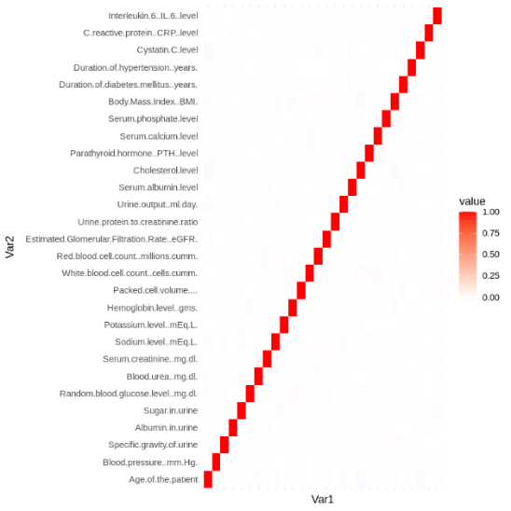

The results of the correlation analysis above show that each numeric predictor variable does not have a significant linear relationship with other numeric variables, as indicated by the neutral or near transparent 'box' color.

This also serves as an indicator of the presence of multicollinearity, which is a condition where two or more numeric variables have a high correlation with each other. In the absence of multicollinearity, the regression model becomes more balanced, and the estimated coefficient values can also be interpreted more accurately.

- Numerical Predictor Variables Boxplot

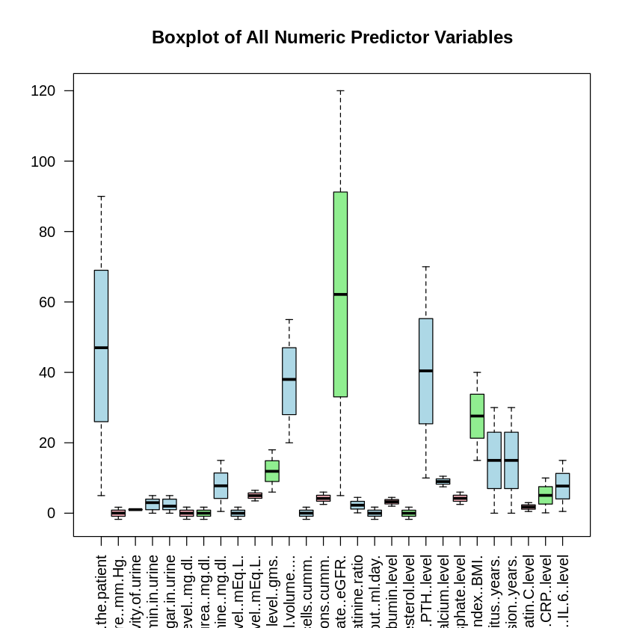

The boxplot shows the five-number summary of the values within each of the numerical predictor variables; it consists of the lowest value, the first, second, and third quartile, as well as the highest value. The box in the middle represents the Interquartile Range (IQR), which contains 50% of the total data of each variable and the line within it shows the second quartile or the median of the data.

From the plot, it is concluded that there’s no outliers in each of the numerical variables since no value is outside the range of the five-number summary.

- Categorical Variables Distribution

a. Red Blood Cells within the Urine

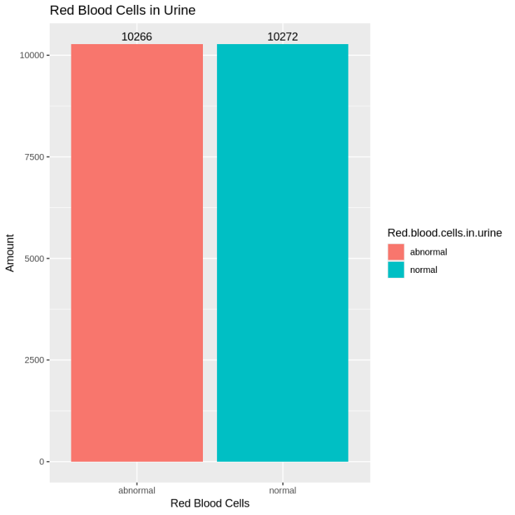

The bar chart above shows the distribution of the values in the categorical variable “Red.blood.cells.in.urine”, with very slightly more patients having normal red blood cells in their urine compared to the ones with abnormal red blood cells.

b. Presence of White Blood Cells within the Urine

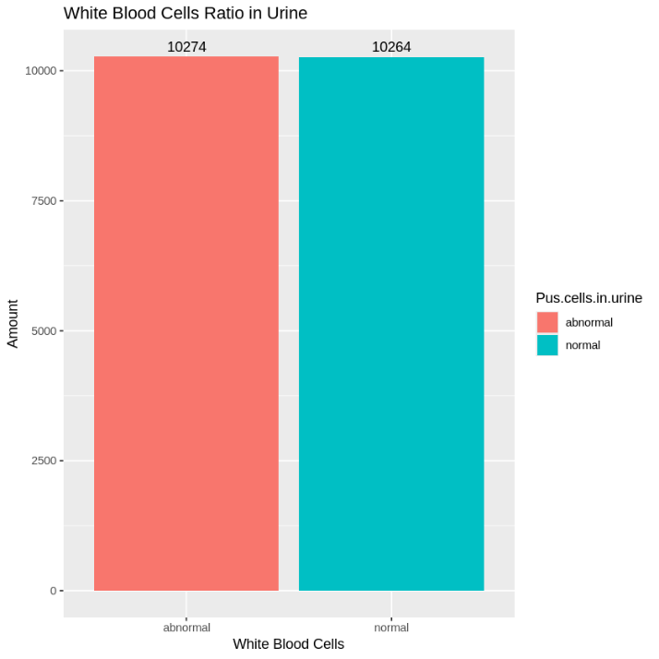

The bar chart above shows the distribution of the values within the categorical variable “Pus.cell.in.urine”, which is an indicator of the amount and shape of white blood cells in the urine with very slightly more patients having normal white blood cells in their urine compared to the ones with abnormal white blood cells.

c. Severe Urinary Infection

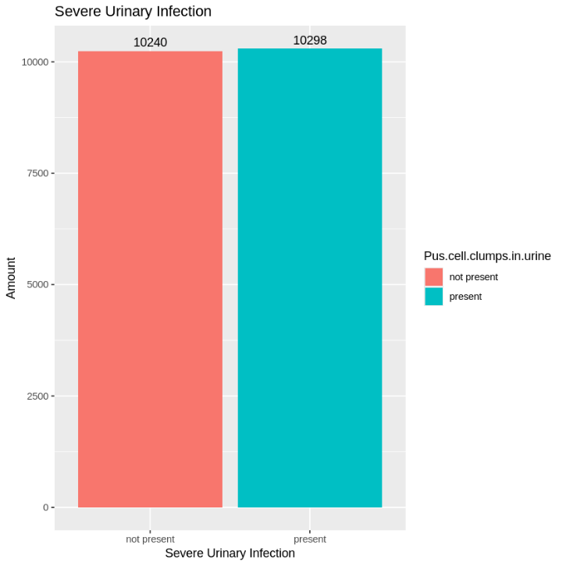

The bar chart above shows the distribution of the values in the categorical variable “Pus.cell.clumps.in.urine”, which is an indicator if a severe urinary infection is present or not, with very slightly more patients having severe urinary infection than those who don't.

d. Bacteria in Urine

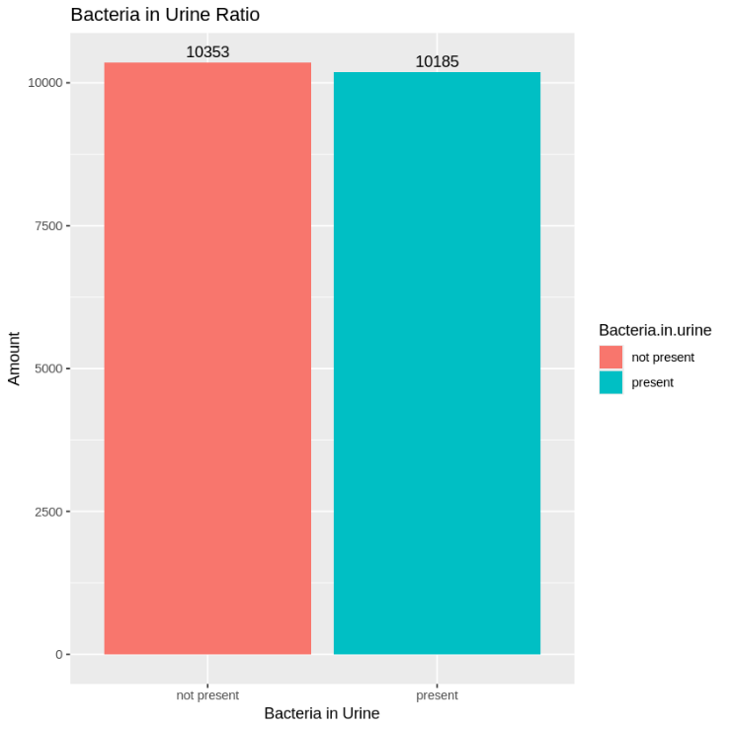

The bar chart above shows the distribution of the values within the categorical variable “Bacteria.in.urine”, which is an indicator if bacteria is present in the urine or not, with very slightly more patients not having bacteria in their urine than those who do.

e. Hypertension

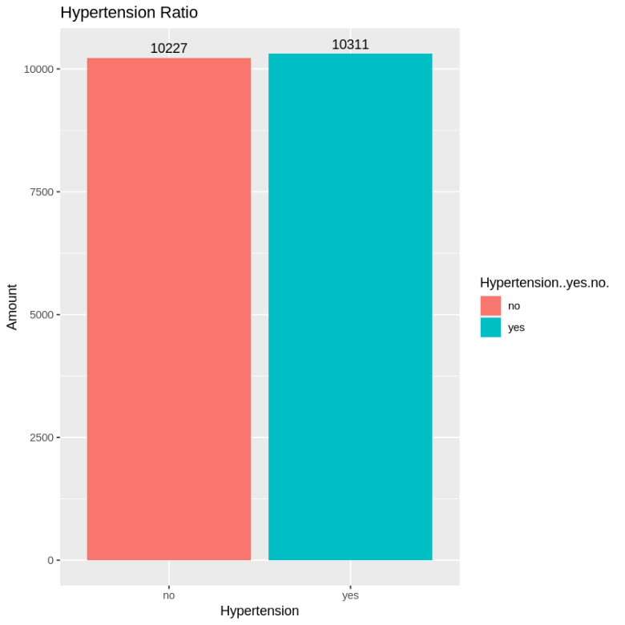

The bar chart above shows the distribution of the values within the categorical variable “Hypertension..yes.no.”, which is an indicator if hypertension is present or not, with very slightly more patients having hypertension than those who don’t.

f. Diabetes Mellitus

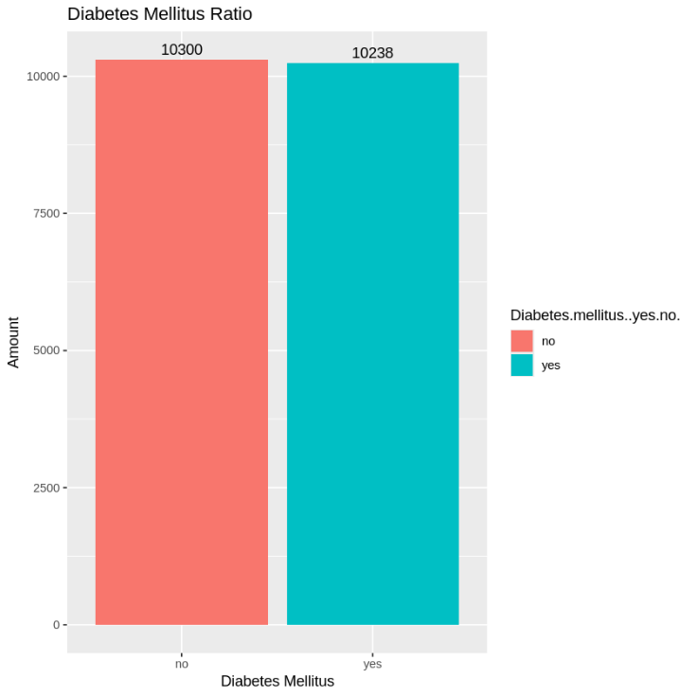

The bar chart above shows the distribution of the values within the categorical variable “Diabetes.mellitus..yes.no.”, which is an indicator if diabetes mellitus is present or not, with very slightly more patients not having diabetes mellitus than those who do.

g. Coronary Artery Disease

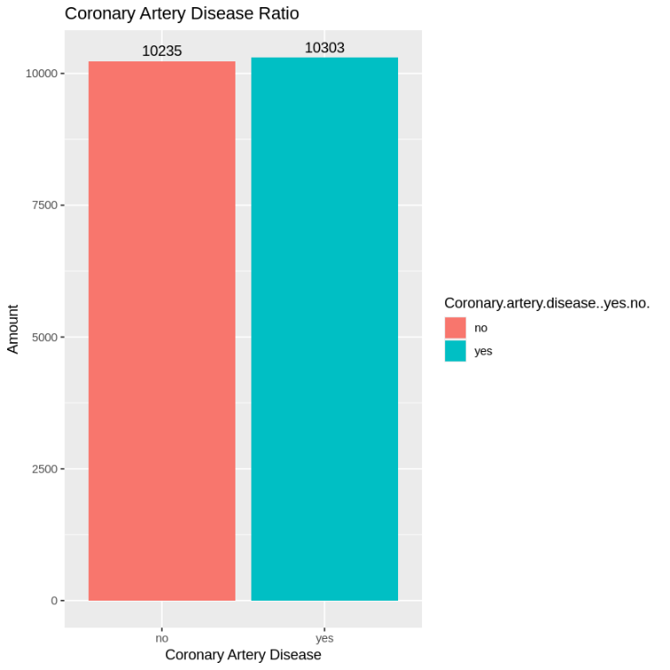

The bar chart above shows the distribution of the values within the categorical variable “Coronary.artery.disease..yes.no.”, which is an indicator if a coronary artery disease is present or not, with very slightly more patients having coronary artery disease than those who don’t.

h. Appetite

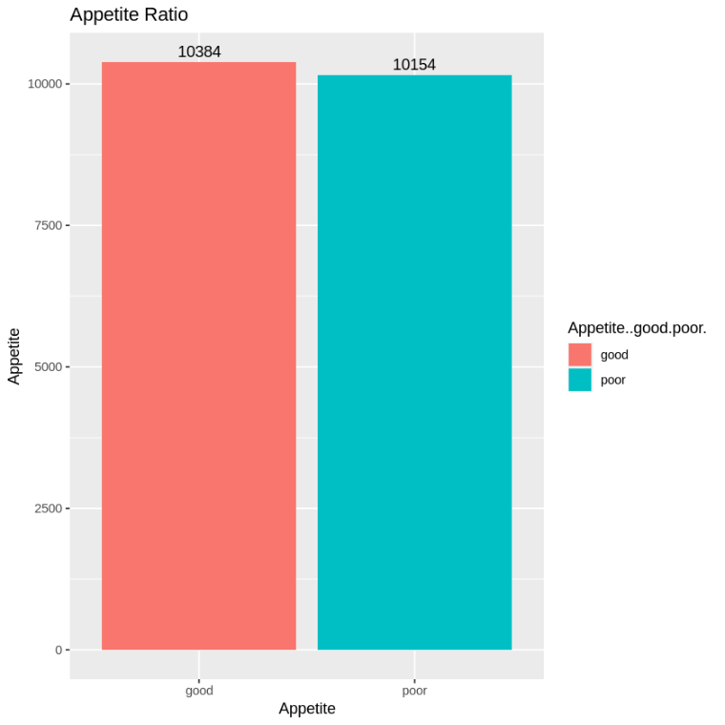

The bar chart above shows the distribution of the values within the categorical variable “Appetite..yes.no.”, which is an indicator of a good appetite or not, with very slightly more patients having a good appetite than those who don’t.

i. Pedal Edema

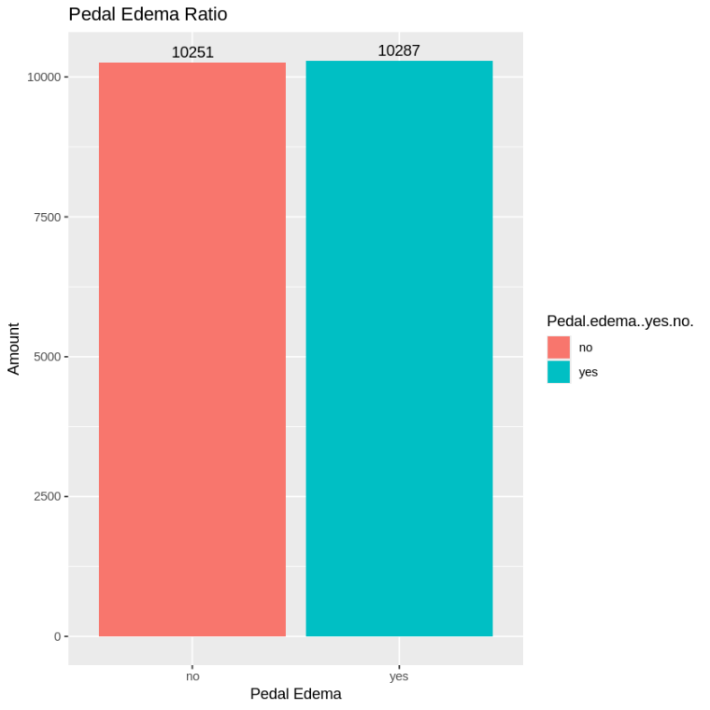

The bar chart above shows the distribution of the values in the categorical variable “Pedal.edema..yes.no.”, which is an indicator if pedal edema is present or not. Pedal edema is swelling of the feet and ankles due to accumulation of fluids in the tissues, with slightly more patients having it than those who don’t.

j. Anemia

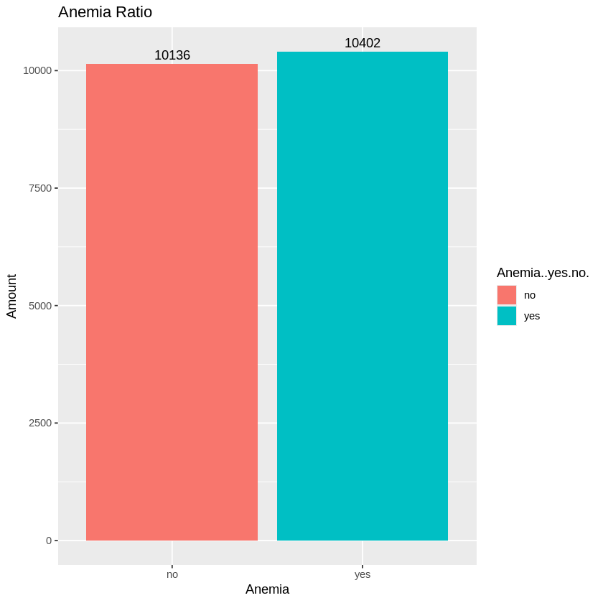

The bar chart above shows the distribution of the values within the categorical variable “Anemia..yes.no.”, which is an indicator if anemia is present or not, with slightly more patients having anemia than those who don’t.

k. Family History of CKD

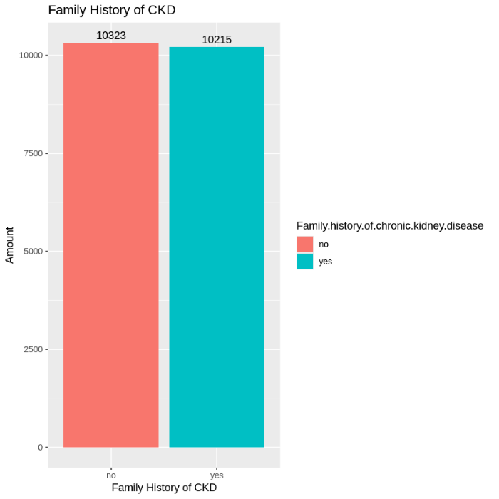

The bar chart above shows the distribution of the values within the categorical variable “Family.history.of.chronic.kidney.disease”, which is an indicator if CKD is present or not in their family history, with slightly more patients not having a family history of CKD than those who do.

l. Smoking Status

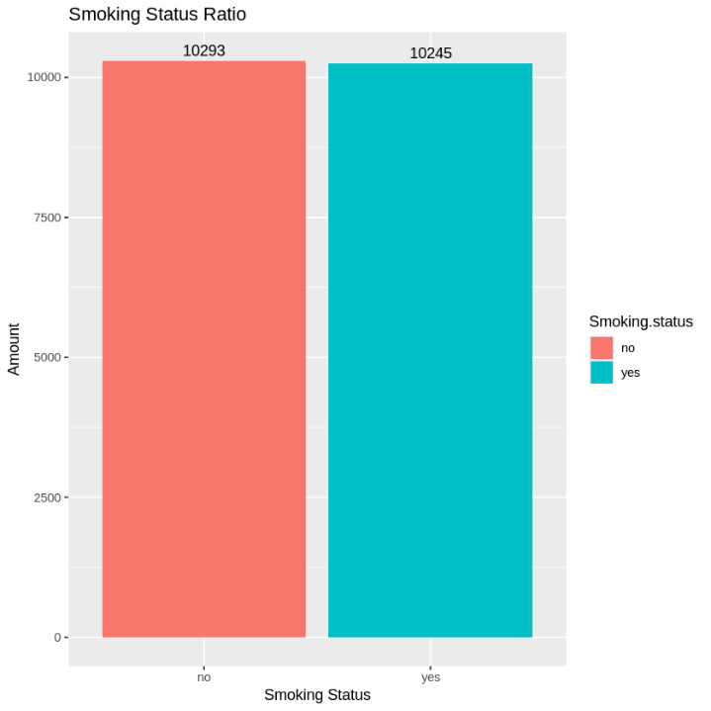

The bar chart above shows the distribution of the values within the categorical variable “Smoking.status”, which is an indicator if they’re an active smoker or not, with slightly more patients being an active smoker than those who aren’t.

m. Physical Activity Level

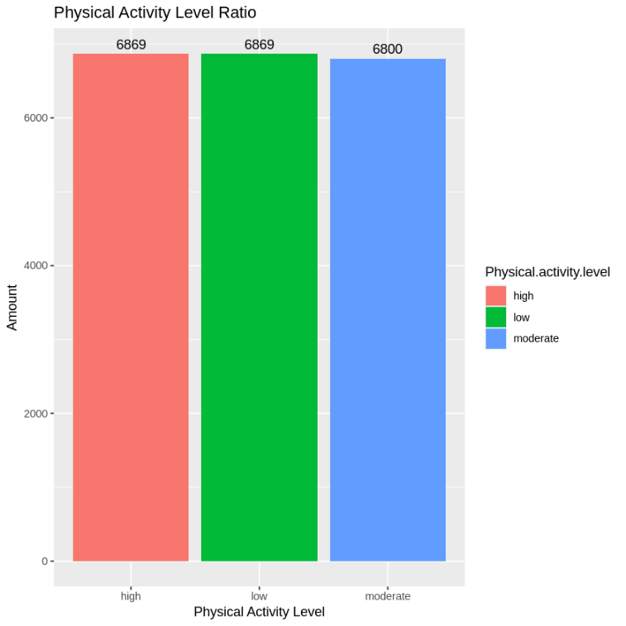

The bar chart above shows the distribution of the values in the categorical variable “Physical.activity.level”, which is an indicator of their physical activity level ranging from low to high, with patients at a high and low physical activity level having the same amount and at a moderate level having a slightly lower amount.

n. Urinary Sediment Microscopy Result

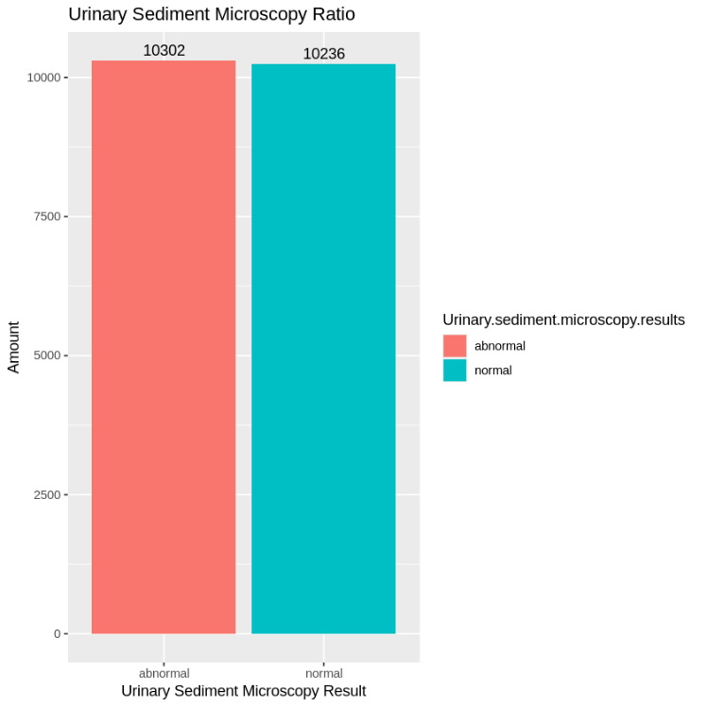

The bar chart above shows the distribution of the values within the categorical variable “Urinary.sediment.microscopy.results”, which is an indicator of the result of their microscopy urinary sediment result where it examines the solid components within the urine, with slightly more patients having an abnormal result than those who have normal ones.

o. Risk Level

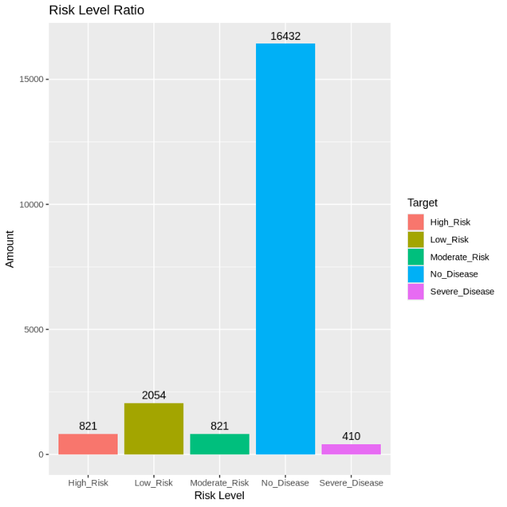

The bar chart above shows the distribution of the values within the categorical variable “Target”, which is an indicator of the risk levels of kidney disease, with patients not having any disease having a much higher amount than the others.

Model Testing

To properly assess the significance of the predictor variables within the model, this section provides the result for both the Likelihood Ratio Test (LRT) and the Wald Test, along with the accuracy of the model to analyze how well the model predicts the outcome of the target variable.

- Likelihood Ratio Test (LRT)

Likelihood Ratio Test Result
 | Model
 | FULL | NULL
Residual df | 20492 | 20534
Residual Deviance | 30515.44572 | 30571.05406
Test | 1 vs 2 | -
Degrees of Freedom (df) | 42 | N/A
Likelihood Ratio Statistic | 55.608341 | N/A
P - Value (Chi-Square) | 0.07776217 | N/A

The table above are the results of the Likelihood Ratio Test, following the chi-square distribution. The obtained p-value is 0.07776217, which is higher than our established significance level (0.05).

Following the results, it is concluded that we failed to reject H0, which implies that The null model is sufficient in explaining the data which means collectively, all the coefficient values of the predictor variables are equal to 0.

- Wald Test

Wald Test Result
Variable | Coefficient Value | P - Value
Age.of.the.patient | 0.0010124 | 0.14568728
Blood.pressure..mm.Hg. | -0.01295175 | 0.455488468
Specific.gravity.of.urine | 5.044545758 | 2.19E-245
Albumin.in.urine | -0.013374607 | 0.191378499
Sugar.in.urine | -0.002172709 | 0.831511702
Red.blood.cells.in.urine | 0.040019605 | 0.249190073
Pus.cells.in.urine | 0.131236942 | 0.000159188
Pus.cell.clumps.in.urine | -0.003357223 | 0.922925668
Bacteria.in.urine | -0.016074046 | 0.643247438
Random.blood.glucose.level..mg.dl. | 0.006831615 | 0.694013387
Blood.urea..mg.dl. | -0.002874476 | 0.868472811
Serum.creatinine..mg.dl. | -0.002198649 | 0.596840466
Sodium.level..mEq.L. | -0.012816892 | 0.460168113
Potassium.level..mEq.L. | -0.003042658 | 0.878664996
Hemoglobin.level..gms. | 0.00608108 | 0.227030218
Packed.cell.volume.... | -0.002303573 | 0.166865087
White.blood.cell.count..cells.cumm. | -0.015216479 | 0.380960581
Red.blood.cell.count..millions.cumm. | 0.006527306 | 0.703925872
Hypertension..yes.no. | 0.062842004 | 0.070357316
Diabetes.mellitus..yes.no. | 0.025845816 | 0.456904893
Coronary.artery.disease..yes.no. | 0.013992583 | 0.686772921
Appetite..good.poor. | 0.094469376 | 0.006516641
Pedal.edema..yes.no. | 0.064054531 | 0.064988665
Anemia..yes.no. | -0.015953637 | 0.645741425
Estimated.Glomerular.Filtration.Rate..eGFR. | -0.00117115 | 0.024389407
Urine.protein.to.creatinine.ratio | -0.001351229 | 0.921119235
Urine.output..ml.day. | -0.019282126 | 0.266615353
Serum.albumin.level | 0.022403897 | 0.351129138
Cholesterol.level | -0.009828273 | 0.571756878
Parathyroid.hormone..PTH..level | 0.001260435 | 0.208472638
Serum.calcium.level | 0.011221657 | 0.574919389
Serum.phosphate.level | -0.002576618 | 0.881257783
Family.history.of.chronic.kidney.disease | 0.001317012 | 0.969741063
Smoking.status | 0.013165456 | 0.704476223
Body.Mass.Index..BMI. | 0.000276959 | 0.908344874
Physical.activity.level | 0.016708564 | 0.430986848
Duration.of.diabetes.mellitus..years. | 0.001443887 | 0.455300589
Duration.of.hypertension..years. | -0.00139989 | 0.47031356
Cystatin.C.level | -0.007564103 | 0.753704809
Urinary.sediment.microscopy.results | -0.016053825 | 0.64395862
C.reactive.protein..CRP..level | 0.004609113 | 0.448275557
Interleukin.6..IL.6..level | 0.000861952 | 0.834945037
High_Risk|Low_Risk | 2.319750207 | 1.53E-55
Low_Risk|Moderate_Risk | 3.684631555 | 8.55E-137
Moderate_Risk|No_Disease | 3.984093545 | 1.76E-159
No_Disease|Severe_Disease | 9.407876819 | 0

From the table above, four variables are concluded to be a significant predictor to the risk level of chronic kidney disease, with those predictor variables being:

- Concentration of urine used to assess the filtering ability of the kidney (specific.gravity.of.urine)
- Presence of white blood cells in the urine (pus.cells.in.urine)
- Appetite
- Estimated Glomerular Filtration Rate (eGFR)

The predictor variables above have a p-value lower than 0.05, indicating that we reject H0 for each of the predictor variables hypothesis test. Based on the theory of the Wald Test method, they are deemed significant in affecting the outcome of the risk level for CKD.

Not only that, the coefficient value can be used to determine if the variable is positively or negatively affecting the probability of someone having a higher risk of CKD.

According to recent clinical and epidemiological research, these variables are not only statistically significant, but also biologically and clinically relevant in determining chronic kidney disease severity.

For instance, according to research by Gounden, V., et al. (2024), specific gravity of urine (USG) is the kidney’s ability to concentrate urine or dilute urine. Normal USG values range from 1.003 to 1.030. In patients with kidney disease, USG becomes fixed at 1.010, reflecting the specific gravity of glomerular filtrate and indicating a loss of the kidney’s ability to concentrate or dilute urine.

According to research by Thangarajah, B., et al (2025), they found that pus cells in urine (pyuria) is highly prevalent in CKD, not only from urinary tract infections, but also from sterile kidney inflammation. The detection of pyuria offers more than infection, it may indicate underlying inflammatory processes in the kidney. Sterile pyuria presence in CKD patients comes out as an important clinical marker of CKD severity.

Patients with CKD frequently experienced decreased appetite (Anorexia), with prevalence increasing significantly in higher CKD stages. According to Carrero & González-Ortiz (2022), up to 40-50% of dialysis patients report anorexia, driven by by various interrelated factors, such as: disrupted metabolic signaling, gastrointestinal dysfunction, dialysis-specific influences, as well as depression and cultural eating habits. These combined mechanisms result in protein-energy wasting, which is strongly associated with worsening morbidity and mortality in CKD patients, highlighting appetite as an important clinical marker of CKD severity.

Estimated Glomerular Filtration Rate (eGFR) is an important clinical marker for diagnosing and staging CKD. According to Vaidya, S. R. & Aeddula, N. R. (2024), CKD is marked by eGFR less than 60 mL/min/1.73m², persisting for 3 months or longer. The KDIGO classification system uses eGFR to stage CKD from G1 ($≥$ 90) to G5 (<15), with lower values indicating higher CKD severity, highlighting eGFR as an important clinical marker of CKD severity.

In conclusion, these four variables, specific gravity of urine, pus cells in urine, appetite, and eGFR are not only statistically significant, but also clinically important in assessing CKD severity. They serve as clear clinical markers of kidney damage and help both healthcare professionals and the general public better understand, monitor, and manage the progression of the disease.

- Accuracy

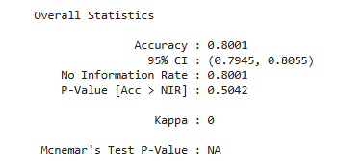
The figure above shows the overall statistics of the Ordinal Logistic Regression model with the accuracy being the main take away. An accuracy of 0.8001 means that the model successfully predicts the correct outcome in 80.01% of cases. This indicates that the model performs pretty reliably in reflecting the interaction between the predictors and target variables.

Odds Ratio (OR)

Below are the odds ratio of the significant variables. These are used to determine if the variable is positively or negatively affecting the probability of a patient having a higher risk of CKD. The formula are as follows:

OR = e^{β}; where β is the coefficient value

And below are the interpretation of different OR results:

OR = 1; the predictor has no effect on the probability, meaning the coefficient value is equal to 0

OR > 1; the predictor has a positive effect, where the probability of a higher category class rise as the coefficient value is above 0 and increases

OR < 1; the predictor has a negative effect, where the probability of a higher category class declines as the coefficient value is below 0 and decreases

To determine the increase or decrease of a higher class outcome percentage, the formula are as follows:

(OR – 1) x 100%

- Specific gravity of urine

Coefficient Value | exp (Coefficient) | Interpretation
5.044546 | 155.1738343 | Every one unit increase in the concentration of urine, the probability of someone having a higher risk of kidney disease increases by 15.400%, with the assumption that all the other variables remain constant

- Estimated Glomerular Filtration Rate (eGFR)

Coefficient Value | exp (Coefficient) | Interpretation
-0.001171 | 0.99888296854 | Every one unit increase in the estimated glomerular filtration rate, the probability of someone having a higher risk of kidney disease decreases by 0.111%, with the assumption that all the other variables remain constant

Predictor Variable Comparison with Other Researches

The table below shows the comparison of results for the predictor variables found in this research with multiple other research papers from different authors .

Predictor Variable | Other Researches | Our Research
Diabetes mellitus | Significant | Not Significant
Hypertension | Significant | Not Significant
Family history of CKD | Significant | Not Significant
Age | Significant | Not Significant
Smoking Status | Significant | Not Significant
BMI | Significant | Not Significant
Physical activity level | Significant | Not Significant
Interleukin level | Significant | Not Significant
C reactive protein level | Significant | Not Significant
Albumin in urine | Significant | Not Significant
Hemoglobin level | Significant | Not Significant
Serum creatinine | Significant | Not Significant
Specific gravity | Significant | Significant

CONCLUSION

Several significant conclusions were reached from the analysis of the kidney disease dataset using ordinal logistic regression:

Only four of the 42 predictor variables examined were statistically significant predictors of the risk levels for CKD, specifically urine specific gravity. Higher readings are closely linked to higher risk. Urine containing pus cells is a sign of infection or inflammation and is associated with a higher risk. Condition of appetite: More serious kidney disorders are linked to poor appetite. The likelihood of advanced stages of chronic kidney disease is decreased by higher estimated glomerular filtration rate (eGFR) values.

Common risk factors for chronic kidney disease (CKD) that were not statistically significant in this dataset included diabetes mellitus, hypertension, age, family history, BMI, and inflammatory markers (IL-6, CRP). This implies that either their effects are mediated by other variables or they may not be sufficient to explain the observed population's CKD risk progression on their own.

Model Strength by maintaining the natural order of disease severity, the ordinal logistic regression approach to CKD progression provides a more nuanced understanding than nominal categorization models.

The results can help medical professionals locate important biomarkers and clinical indicators for early screening. They can also serve as a foundation for creating decision support systems that use machine learning.

REFERENCES

[1] Webster, A. C., Nagler, E. V., Morton, R. L., Masson, P. (2017). Chronic kidney disease. The Lancet, 389(10075), 1238–1252. https://doi.org/10.1016/S0140-6736(16)32064-5

[2] Vaidya, S. R., & Aedulla, N. R. (2025). Chronic kidney disease. Treasure Island (FL): StatPearls Publishing. https://www.ncbi.nlm.nih.gov/books/NBK535404/

[3] Arora, P. (2025). Chronic kidney disease (CKD). Medscape. https://emedicine.medscape.com/article/238798

[4] GBD Chronic Kidney Disease Collaborators. (2020). Global, regional, and national burden of chronic kidney disease, 1990–2017: A systematic analysis for the Global Burden of Disease Study 2017. The Lancet, 395(10225), 709–733. https://doi.org/10.1016/S0140-6736(20)30045-3

[5] Tim Riskesdas. (2018). Laporan nasional Riskesdas 2018. Badan Penelitian dan Pengembangan Kesehatan, Kementerian Kesehatan RI. https://repository.badankebijakan.kemkes.go.id/id/eprint/3514/

[6] Levin, A., et al. (2017). Global kidney health 2017 and beyond: A roadmap for closing gaps in care, research, and policy. The Lancet, 390(10105), 1888–1917. https://doi.org/10.1016/S0140-6736(17)30788-2

[7] Francis, A., et al. (2024). Chronic kidney disease and the global public health agenda: An international consensus. Nature Reviews Nephrology, 20, 473–485. https://doi.org/10.1038/s41581-024-00820-6

[8] Ilyas, H., Ali, S., Ponum, M., Hasan, O., Mahmood, M. T., Ifikhar, M., Malik, M. H. (2021). Chronic kidney disease diagnosis using decision tree algorithms. BMC Nephrology, 22(1). https://doi.org/10.1186/s12882-021-02474-z

[9] Tekale, S., Shingavi, P., Wandhekar, S., Chatorikar, A. (2018). Prediction of chronic kidney disease using machine learning algorithm. International Journal of Advanced Research in Computer and Communication Engineering, 7(10), 170–174. http://dx.doi.org/10.17148/IJARCCE.2018.71021

[10] Tabassum, S., G, M. B. B., Majumdar, J. (2017). Analysis and prediction of chronic kidney disease using data mining technique. ResearchGate. http://dx.doi.org/10.13140/RG.2.2.26856.72965

[11] Islam, M. A., Majumder, M. Z. H., Hussein, M. A. (2023). Chronic kidney disease prediction based on machine learning algorithms. Journal of Pathology Informatics, 14, 100189. https://doi.org/10.1016/j.jpi.2023.100189

[12] Halder, R. K., Uddin, M. N., Uddin, M. A., Aryal, S., Saha. S., Hossen, R., Ahmed, S., Rony, M. A. T., Akter, M. F. (2024). ML_CKDP: Machine learning-based chronic kidney disease prediction with smart web application. Journal of Pathology Informatics, 15, 100371. https://doi.org/10.1016/j.jpi.2024.100371

[13] Dharmapatni, N. W. K., Adnyana, I. K. B., Strisanti, I. A. S., Harditya, I. K. B., Damayanti, I. A. M., & TreesnaWulansari, N. (2024, April 20). ANALISIS FAKTOR YANG MEMPENGARUHI SELF AWARENESS MASYARAKAT TERHADAP FAKTOR RISIKO PENYAKIT GINJAL KRONIK (PGK) DI BALI. The Shine Cahaya Dunia Ners, 09. https://doi.org/10.35720/tscners.v9i01.473

[14] Hu, J., Ke, R., Teixeira, W., Dong, Y., Ding, R., Yang, J., Ai, X., Ye, D.-W., & Shang, J. (2022, January 18). Global, Regional, and National Burden of CKD due to Glomerulonephritis from 1990 to 2019. Clin J Am Soc Nephrol, 18. https://doi.org/10.2215/CJN.0000000000000017

[15] Ikizler, T. A., Burrowes, J. D., Byham-Gray, L. D., Campbell, K. L., Carrero, J.-J., Chan, W., Fouque, D., Friedman, A. N., Ghaddar, S., goldstein-Fuchs, D. J., Kaysen, G. A., Kpple, J. D., Teta, D., Wang, A. Y.-M., & Cuppari, L. (2020, September). KDOQI Clinical Practice Guideline for Nutrition in CKD: 2020 Update. Erratum in: Am J Kidney Dis. https://doi.org/10.1053/j.ajkd.2020.05.006

[16] Jusuf, H., Adityaningrum, A., & Rahim, E. (2024, January 23). ANALISIS REGRESI LOGISTIK ORDINAL UNTUK MENGETAHUI FAKTOR-FAKTOR YANG MEMPENGARUHI KEJADIAN STUNTING DI KECAMATAN BATUDAA PANTAI. Jambura Journal of Health Sciences and Research...... https://doi.org/10.35971/jjhsr.v6i1.21206

[17] Kadatane, S. P., Satariano, M., Massey, M., Mongan, K., & Raina, R. (2023, June 07). The Role of Inflammation in CKD (A. Mitrofanova, Ed.). Cells, 12(12). https://doi.org/10.3390/cells12121581

[18] Khullar, D., Singh, N. P., & Gupta, A. K. (2024, March 15). Revolutionising CKD Care: Novel Treatment Paradigms and Cutting-edge Strategies. Department of Nephrology and Renal Transplant Medicine, Max Super Speciality Hospital, Saket, New Delhi.

[19] Mardianto, R., Sekti, B. H., & Higantara, G. R. (2022, September 28). Pengaruh Kepatuhan Minum Obat Antihipertensi terhadap Kualitas Hidup Pasien di Puskesmas Beji Batu. PHARMADEMICA : Jurnal Kefarmasian dan Gizi, 2. https://doi.org/10.54445/pharmademica.v2i1.21

[20] Tangri, N., Moriyama, T., Schneider, M. P., Vrigitti, J. B., Nicola, L. D., Arnold, M., Barone, S., Peach, E., Wittbrodt, E., Chen, H., Järbrink, K., & Kushner, P. (2023, May 22). Prevalence of undiagnosed stage 3 chronic kidney disease in France, Germany, Italy, Japan and the USA: results from the multinational observational REVEAL-CKD study. BMJ Open, 13(5). https://doi.org/10.1136/bmjopen-2022-067386

[21] Yuniarty, T. Y., Erfiani, Indahwati, Fitrianto, A., & K., K. N. (2022, December 31). Regresi Ordinal Logit dan Probit pada Faktor Kesejahteraan Rumah Tangga Petani Tanaman Pangan di Provinsi Sulawesi Tenggara. Jurnal statistika dan aplikasinya, 6(2). https://doi.org/10.21009/JSA.06216

[22] Agresti, A. (2010). Analysis of Ordinal Categorical Data. Wiley. http://doi.org/10.1002/9780470594001

[23] Fullerton, A. S. (2009). A Conceptual Framework for Ordered Logistic Regression Models. Sociological Methods & Research, 38(2), 306-347. https://doi.org/10.1177/0049124109346162

[24] Peterson, B. & Harrell, F. E. (1990). Partial Proportional Odds Models for Ordinal Response Variables. Applied Statistics, 39(2), 205-217. https://doi.org/10.2307/2347760

[25] Pennsylvania State University. (n.d.). 6a.1 – Introduction to hypothesis testing. Penn State Eberly College of Science. https://online.stat.psu.edu/stat500/lesson/6a/6a.1

[26] Pennsylvania State University. (n.d.). 6b.1 – Introduction to hypothesis testing. Penn State Eberly College of Science. https://online.stat.psu.edu/stat500/lesson/6a/6a.2

[27] Gounden, V., Bhatt, H., Jialal, I. (2024). Renal Function Tests. Treasure Island (FL): StatPearls Publishing. https://www.ncbi.nlm.nih.gov/books/NBK507821/

[28] Blocher, N. C. (2025). Specific Gravity. Medscape. https://emedicine.medscape.com/article/2090711/

[29] Thangarajah, B., Gnanakarunyan T. J., Ramachandran, R., Kajenthirasenan, L., Rukshani, R., Weerasinghe, S. M., Dissanayake, H. H. K. P. (2025). WCN25-4006 INCIDENCE OF PYURIA,CULTURE POSITIVITY AND ANTIBIOTIC SENSITIVITY OF ISOLATED PYURIA AND ASSOCIATED FACTORS AMONG CHRONIC KIDNEY DISEASE (CKD) PATIENTS ATTENDING NEPHROLOGY CLINIC, TEACHING HOSPITAL JAFFNA, SRI LANKA. Kidney International Reports, 10(2). https://doi.org/10.1016/j.ekir.2024.11.1344

[30] Akbar, Muhammad and Suliman-ur Rehman. (2024). Assessing the Role of Nutrition Knowledge and Dietary Diversity in Academic Performance of University Students: Ordinal Logistic Regression Analysis. Forman Journal of Economic Studies. 20(2). https://www.fccollege.edu.pk/wp-content/uploads/2024/12/6-Final-Assessing-the-Role-of-Nutrition-Knowledge-and-Dietary-Diversity-in-Academic-Performance-of-University-Students.pdf

[31] Arango-Botero, D., Hernández-Barajas, F., & Valencia-Arias, A. (2023). Misspecification in Generalized Linear Mixed Models and Its Impact on the Statistical Wald Test. Applied Sciences, 13(2), 977. https://doi.org/10.3390/app13020977

[32] Sur, P., Chen, Y. & Candès, E.J. (2019). The likelihood ratio test in high-dimensional logistic regression is asymptotically a rescaled Chi-square. Probab. Theory Relat. Fields 175, 487–558 (2019). https://doi.org/10.1007/s00440-018-00896-9

[33] Carrero, J. J., González-Ortiz, A. (2022). Anorexia and appetite stimulants in chronic kidney disease. In J. D. Kopple, S. G. Massry, D. Fouque (Eds.), Nutritional management of renal disease (4th ed., 893-906). Academic Press. https://doi.org/10.1016/B978-0-12-818540-7.00012-4

